TO SUPPLY LEFTOVER FOOD TO POOR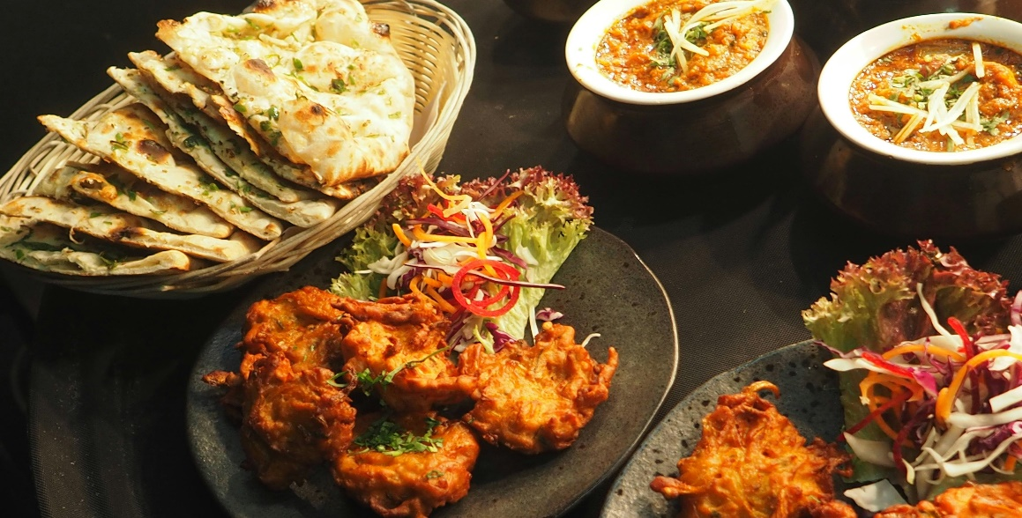

College Name: V N Krishnaswamy Naidu College Of Arts & Science For Women

Team ID: NM2025TMID28295

Team Leader: SHAHANAS NAFIA S

Email: [shahanafaizee2017@gmail.com](mailto:shahanafaizee2017@gmail.com)

Team Members: DHIVYA HARINI R

Email: [dhivyaharini2005@gmail.com](mailto:dhivyaharini2005@gmail.com)

HEMAVARSHINI

Email: [hemavarshini619@gmail.com](mailto:hemavarshini619@gmail.com)

HEMADHARSHINI

Email: [hemadharshinigopal530@gmail.com](mailto:hemadharshinigopal530@gmail.com)

REVATHI

Email: [mrevathi1911@gmail.com](mailto:mrevathi1911@gmail.com)

INTRODUCTION

*The project uses Salesforce to manage and optimize the food distribution process aimed at helping underserved communities. By leveraging Salesforce’s CRM capabilities, the initiative benefits from streamlined data management, efficient volunteer coordination, and real-time insights that improve operations.*

PROJECT GOAL

* Sreamline Food Collection: *Enable donors to easily register and donate leftover food.*
* Optimize Logistics: *Automate route planning and volunteer task assingnment for efficient food distribution.*
* Track and Report: *Monitor donations and generate reports to improve operations*

DEVELOPER ACCOUNT CREATION

*Creating Developer Account:*

*By Using URL:* [*https://developer.salesforce.com/signup*](https://developer.salesforce.com/signup)

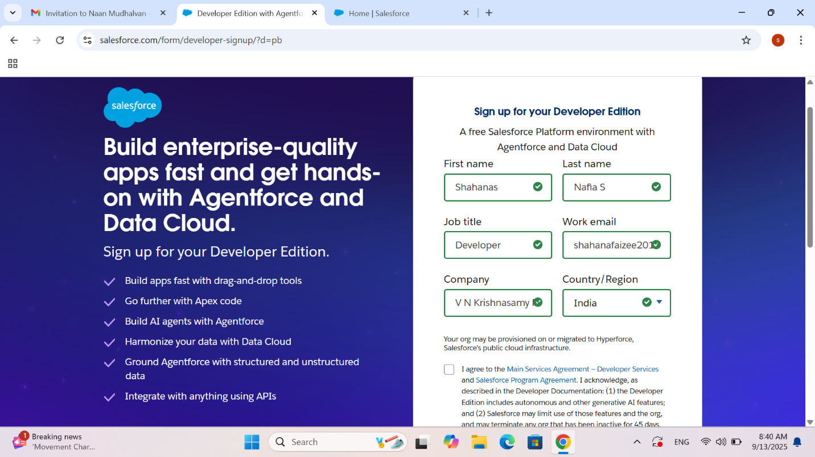

OBJECTS,FIELDS AND ROLES

* Venue: *Manages location where food is collected, with fields for address, contact info, and capacity.*
* Drop-off Point:  *Captures delivery location details, including address and operational hours.*
* Task: *Logs collection and distribution tasks with details such as description, due, date, and assigned volunteer.*
* Volunteer: *Contains volunteer details, such as contact information and availability status.*
* Execution Details: *Tracks each distribution event with start and end dates, quantity of food, and involved volunteers.*

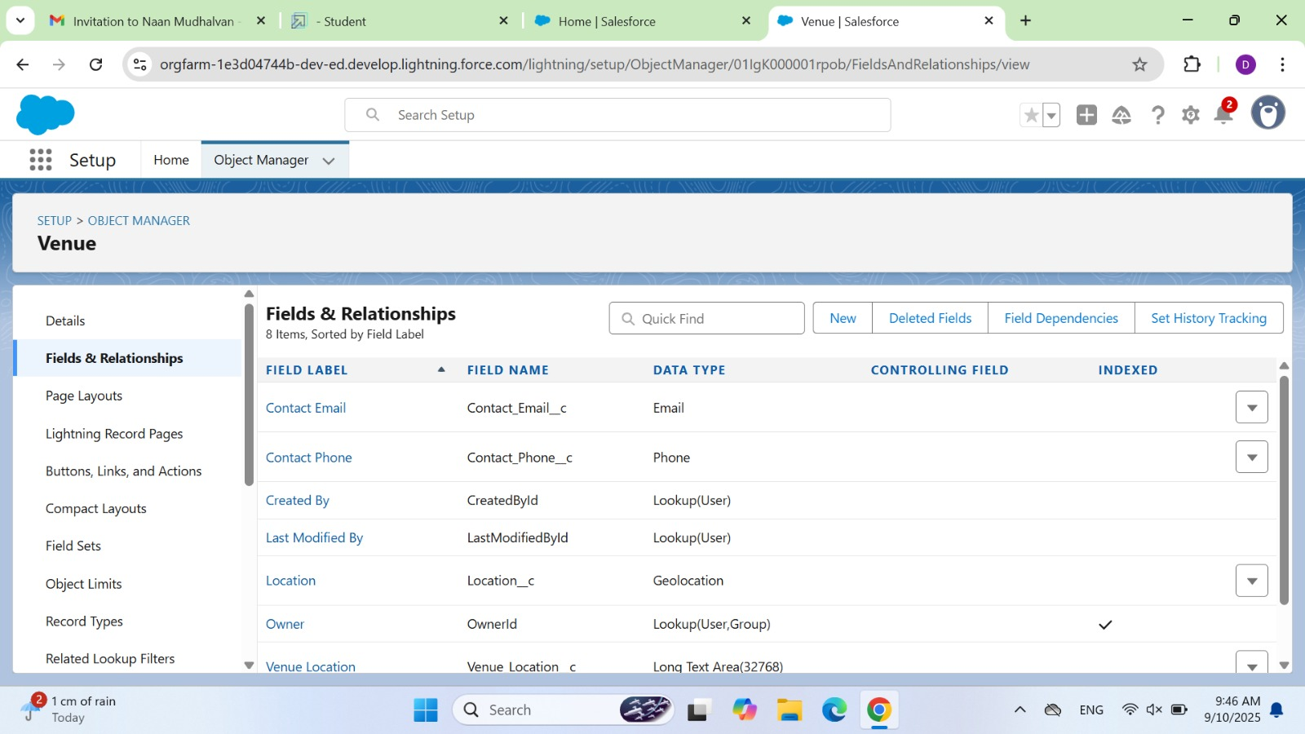

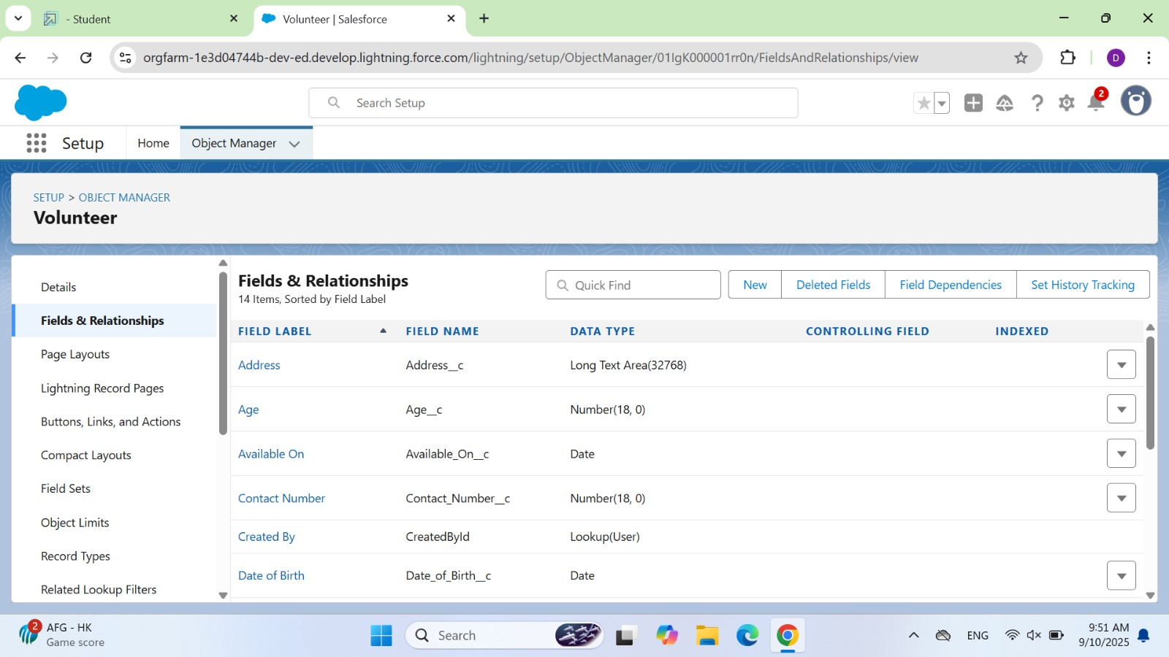

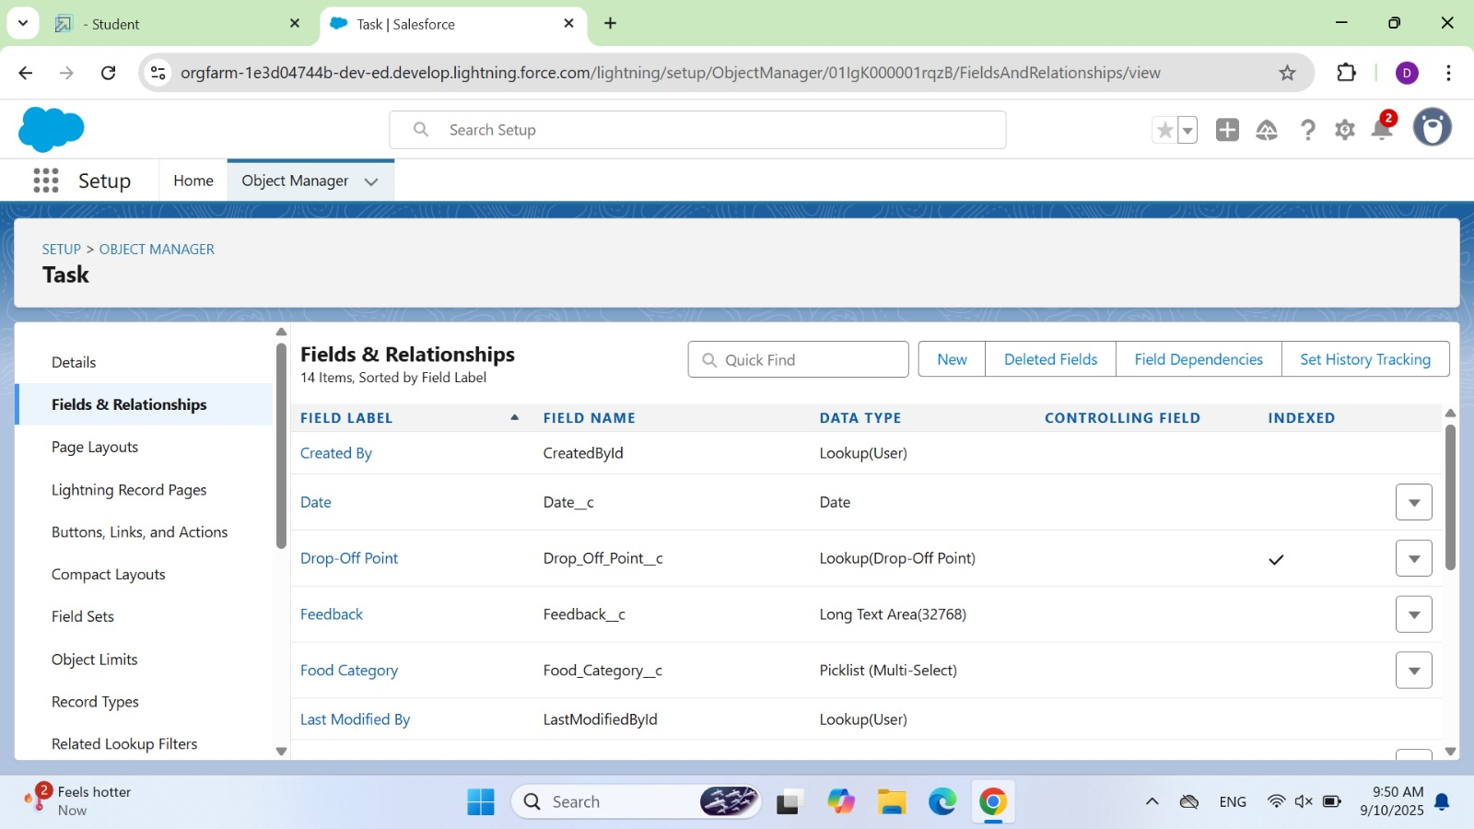

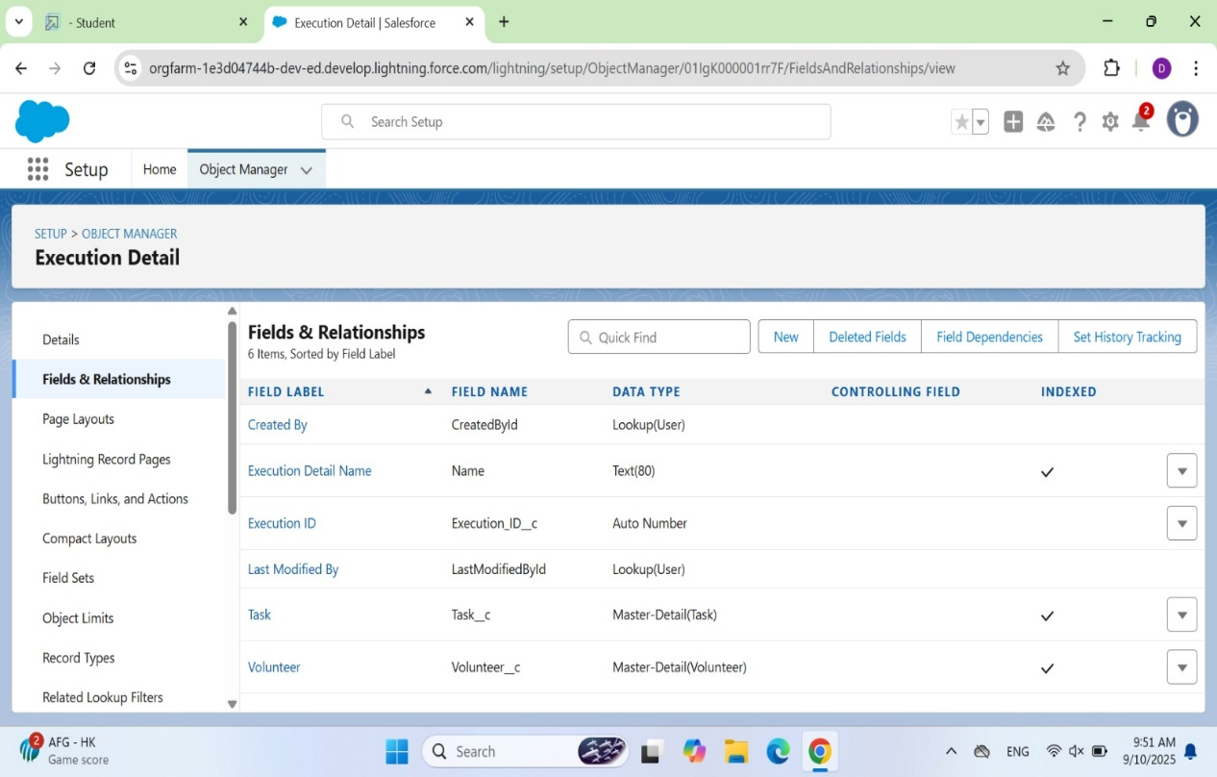

AUTOMATION AND FLOWS

* Screen Flow: *For guided data entry.*
* Record-Triggered Flow: *Automatically initiate tasks upon the creation of specific records.*
* Scheduled Flows:  *Automate routine updates. Example: A flow is set up to create tasks automatically when a new venue record is added, ensuring no manual steps are missed.*

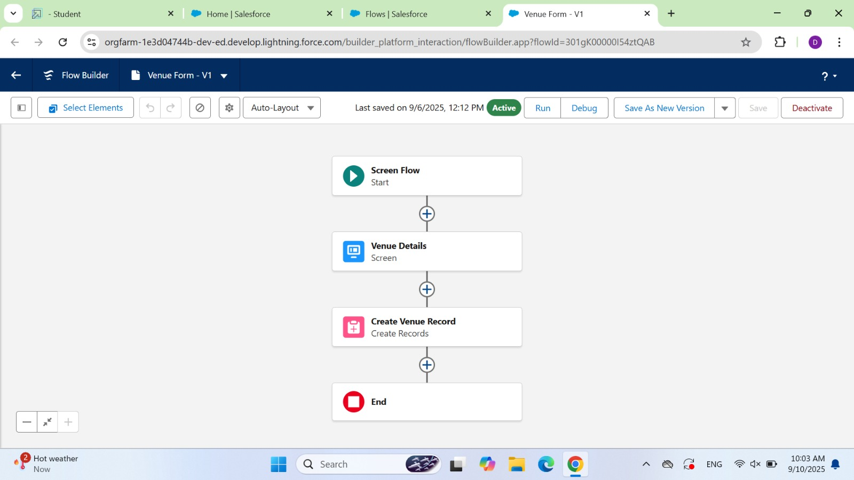

TABS AND PROFILES

* Tabs: *Created for managing data records to objects such as Venue, Drop-off Point, Task, Volunteer and Execution Detail.*

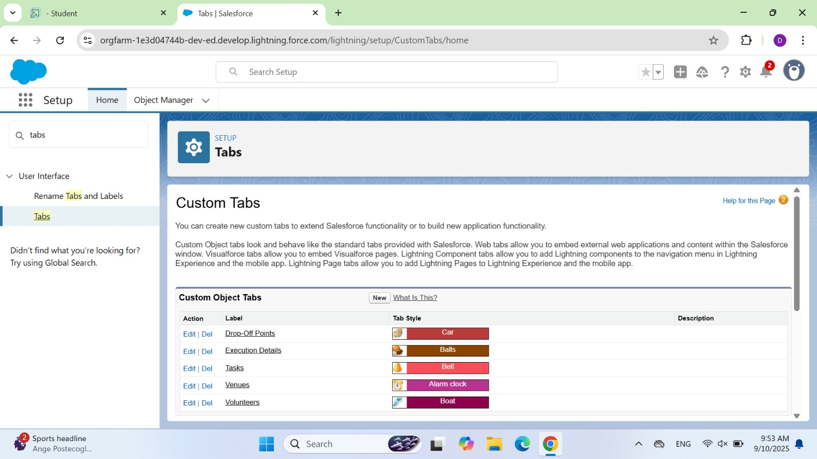

* Profiles: *Created custom profiles to limit data access based on user roles (e.g., Volunteer, Venue manager).*

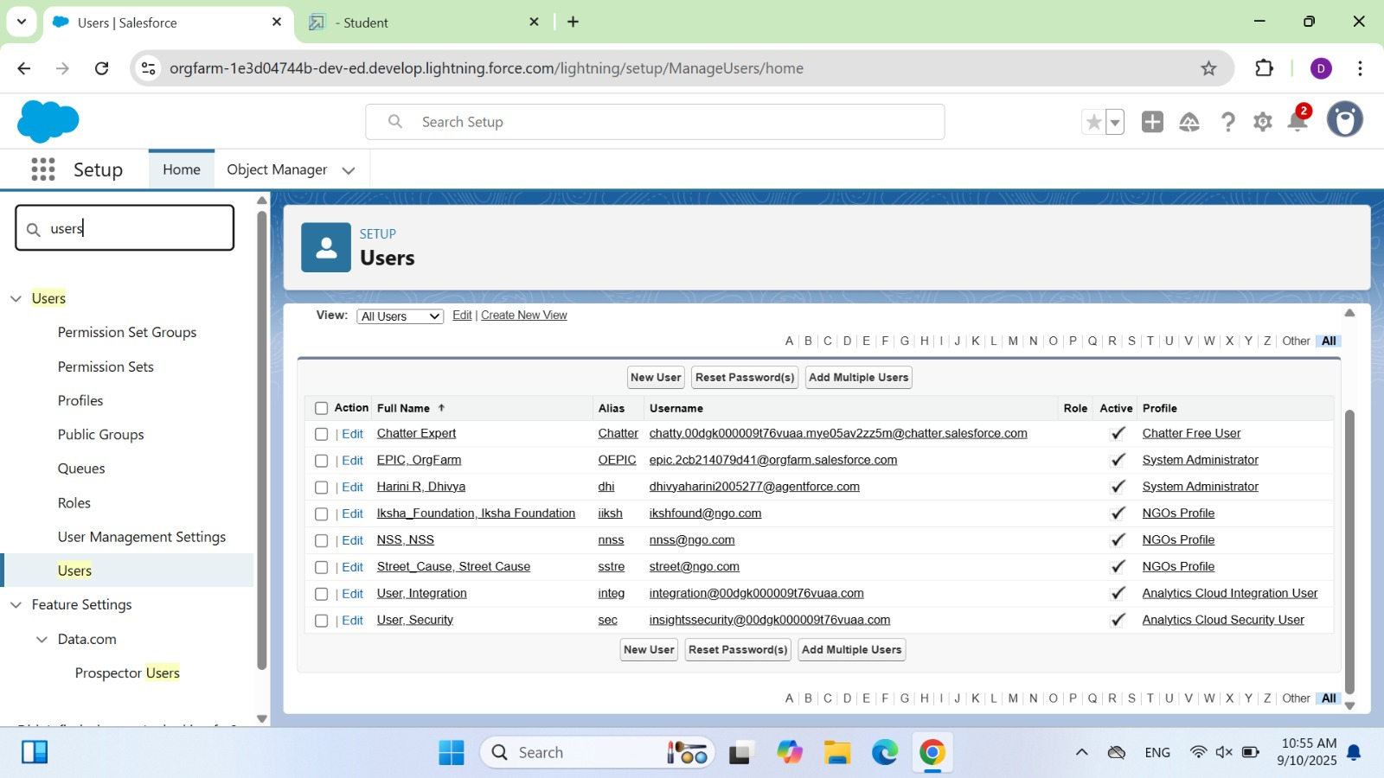

CUSTOM RERORTS AND DASHBOARDS

* Custom Report Types: *Tailored to combine data from objects like Venue, Task and Volunteer for in-depth analysis.*

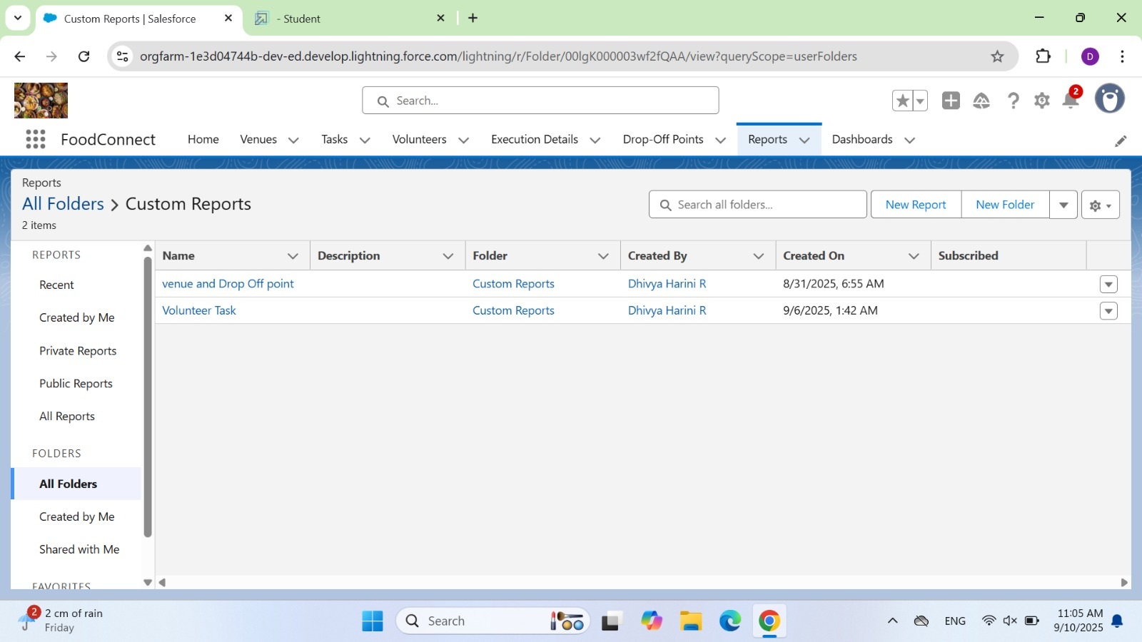

* Dashboard: *Visual representation of key data such as active Venues, Tasks completed, and Volunteer engagement. Components like charts and tables provide project managers with actionable insights.*

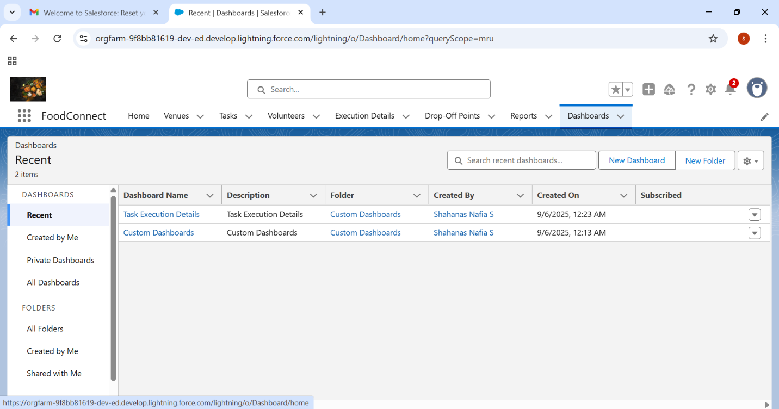

SHARING RULES AND HOMEPAGE

* Sharing rules: *Applied criteria-based sharingrules to ensure records are visible to the appropriate users.*

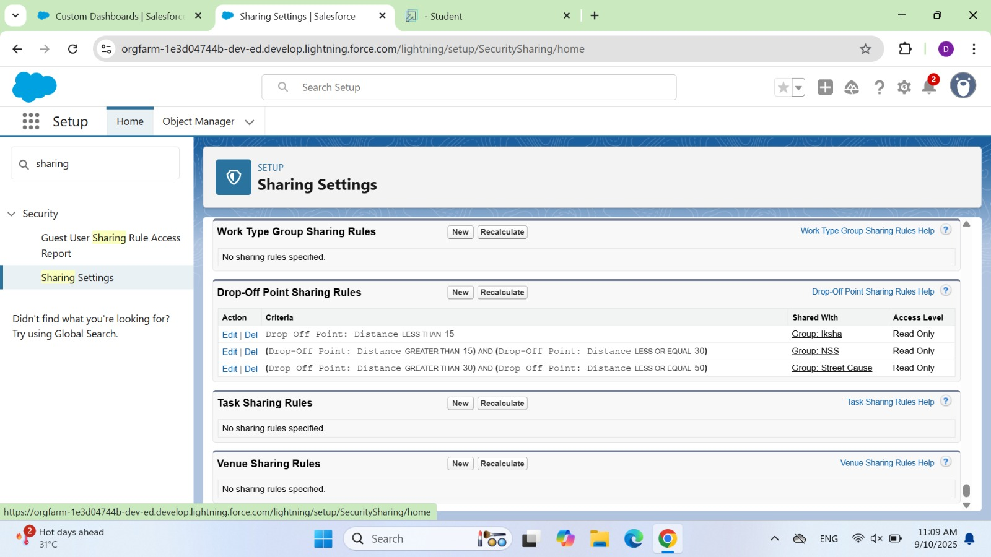

* Homepage: *Tailored with components such as recent Venues, Task, Volunteer, Drop-off point, Execution Detail for easy navigation.*

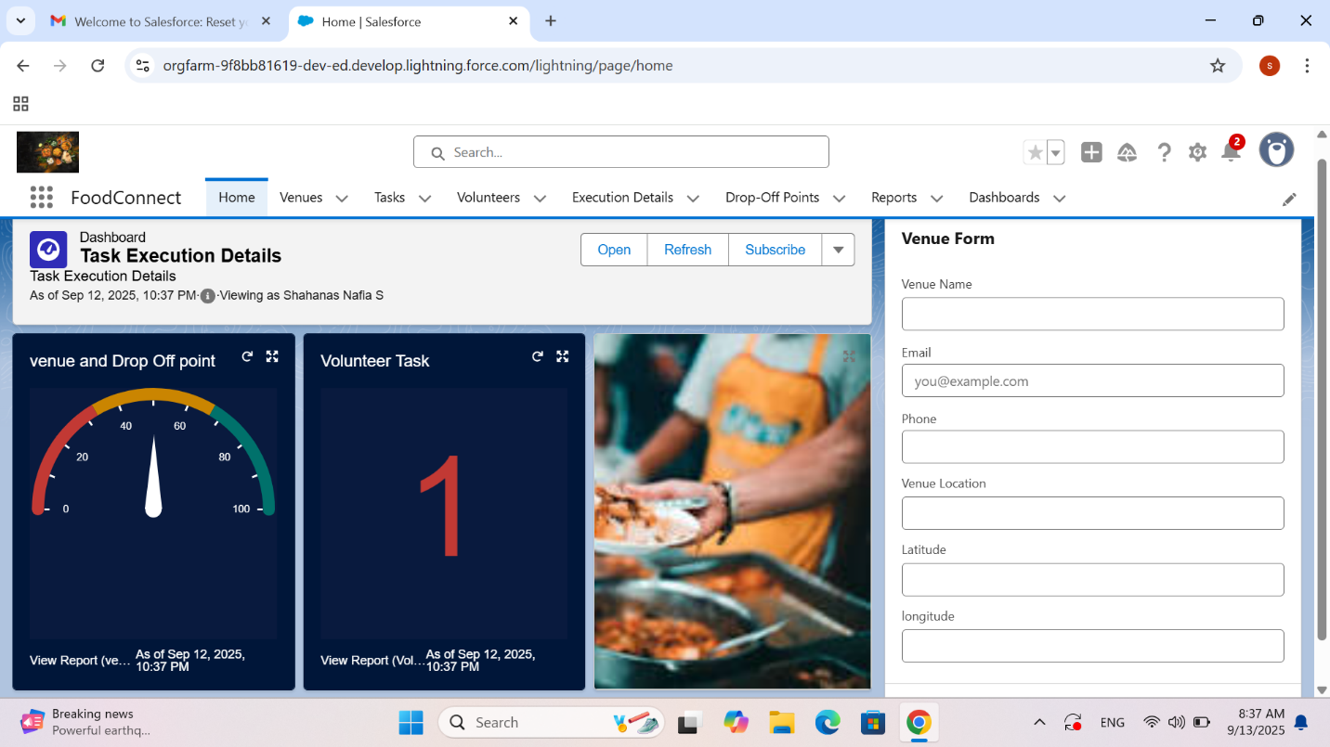

CONCLUSION

* *The project supports community needs through organized food distribution, ensuring donations are utilized effectively.*
* *The project is designed to support growth and expansion.*
* *It reduces manual tasks with automation and secure data handling.*